Formal Report of Group II
Scoring Rubrics for Formal Reports | Points | Score
The question to be answered during the laboratory is stated
The hypothesis clearly shows it is based on research
Research references to prepare the lab are listed
Results of procedure are clearly stated
Summarize the essential laboratory data
State how the essential data answers the lab questions
Report is neatly printed with ink, with no visible corrections
The lab report is written in such a way that others could accurately duplicate the experiment
TOTAL
_{p}h and indicators

- Objectives :

- To prepare a series of acidic and basic solutions by the process of serial dilution; to determine the color changes that inductors undergo when they are in solutions of different degrees of acidity; and to determine the pH of some unknown solution.

- Theoretical Background:
- A serial dilution is the stepwise dilution of a substance in solution. Usually the dilution factor at each step is constant, resulting in a geometric progression of the concentration in a logarithmic fashion. A ten-fold serial dilution could be 1 M, 0.1 M, 0.01 M, 0.001 M... Serial dilutions are used to accurately create highly diluted solutions as well as solutions for experiments resulting in concentration curves with a logarithmic scale. A tenfold dilution for each step is called a logarithmic dilution or log-dilution, a 3.16-fold (10^{0.5}-fold) dilution is called a half-logarithmic dilution or half-log dilution, and a 1.78-fold (10^{0.25}-fold) dilution is called a quarter-logarithmic dilution or quarter-log dilution. Serial dilutions are widely used in experimental sciences, including biochemistry, pharmacology, microbiology, and physics.

- Schematic Procedure:
Put 10 drops of 0.10 mol/L HCI (which has a pH of 1) in well #1 in the first row. Put 10 drops of 0.010 mol/L NaOH which has a pH of 12) in well #12. Put 9 drops of distilled water in wells #2 through #11. You are now ready to begin the serial dilution
Arrange a micro-plate so that there at least 12 columns across the top. Choose four different rows for the different indicators to be tested.

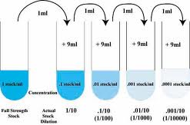
Pull some of the acid solution from well #1 into a dry Beral pipet. Transfer one drop of the acid from well #1 to well #2, and put the rest of the acid back in well #1. Mix well #2 thoroughly by drawing up the entire contents of the well into the pipet and then returning the liquid to the well.
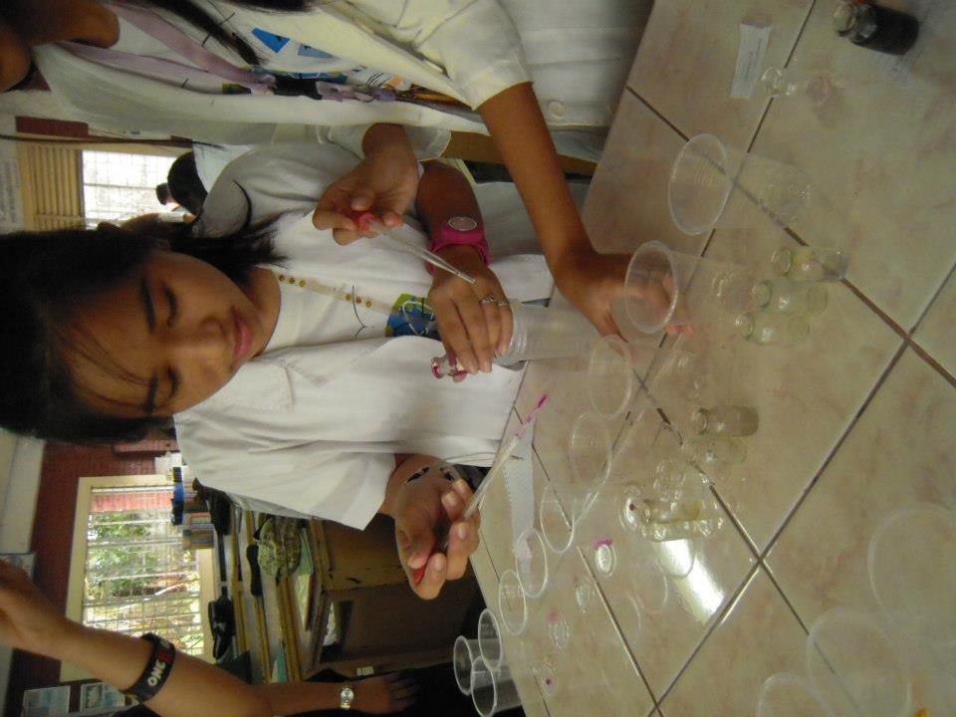
Add one drop of indicator to each well in your first row. Put a drop of phenolphthalein in each well in the second row.

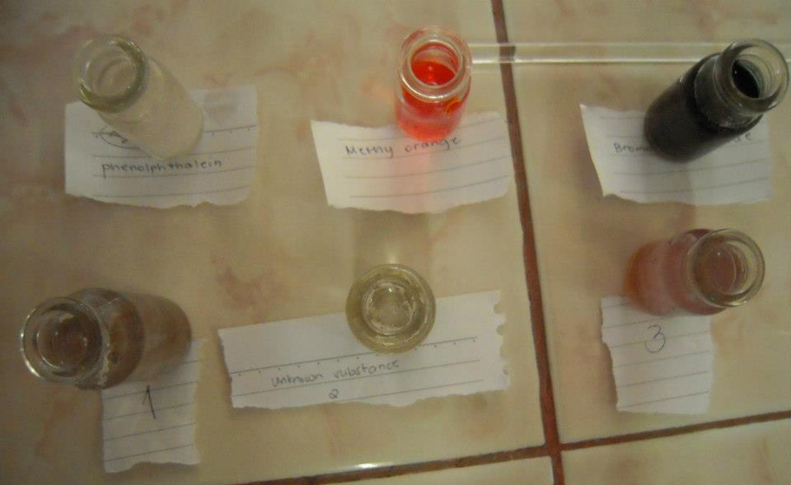
Prepare the indicators

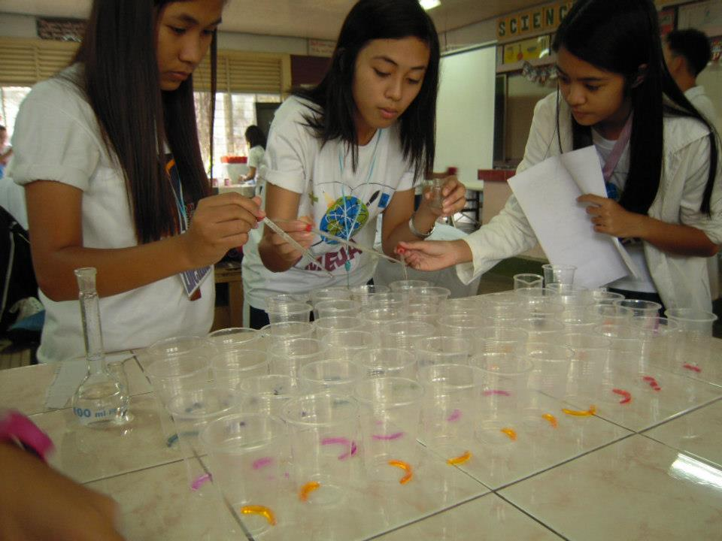
Repeat for the other two unknown solutions.
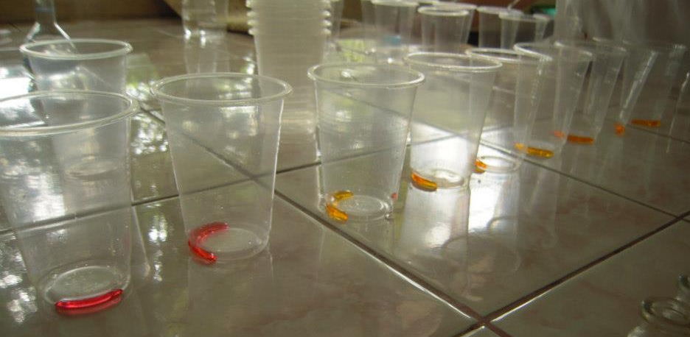
Put 5 drops of the unknown solution in each of 4 wells in a new micro-plate
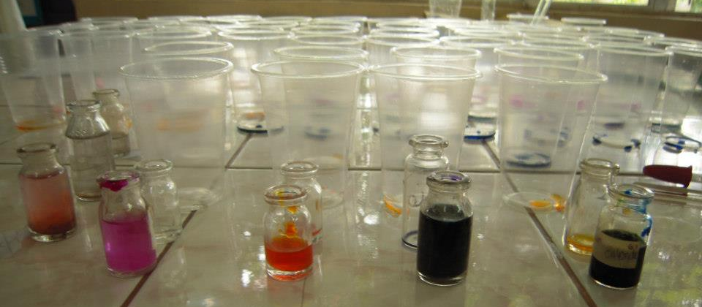
For the three unknown solutions, describe the color changes in each indicator.

IV. Results and Discussions:
Microplate
10a
9+1
10a
9+1
9+1
9+1
10a
9+1
9+1
9+1
10a
9+1
9+1

9+1
9+1
9+1
9+1
9+1
9+1
9+1

9+1
9+1
9+1
9+1

9+1
9+1
9+1
9+1

9+1
9+1
9+1
9+1

9+1
9+1
9+1
9+1

9+1
9+1
9+1
9+1

9+1
9+1
9+1
9+1

10b
10b
10b
10b
- Do you think that the Universal indicator could contain one of the other indicators used in your experiment? Explain.
- Yes, because the term universal means it can be used almost in all materials.
- Explain how the pH values from 1 to 12 were obtained from the dilution process.
- The pH values were obtained using different indicators. By the help of colors, the pH values were obtained
- Explain how you arrived at the pH values of the unknown solutions.
- We determine the pH values of the unknown solutions using the 4 indicators we use, by means of color we can tell whether it is basic or acidic.

- Conclusion
- Using different indicators, we can determine the pH values of the solutions.

- References:
- Group 1 formal Report (2011)
- http://en.wikipedia.org/wiki/PH_indicator
Leader:
Alleta Fae S. Liwag
________________
Members:

Zhenna Marriz Aypa
_________________
Mark Anthony Basilio
_________________
Kathleen Caralde
__________________
Cristel Diane Dela Cruz
__________________
Reagan Delos Reyes
___________________
Cristel F. Imbag
____________________
Jarlyn Liwag
____________________
Rosiel Mariano
_____________________

Submitted to Mr. Jeffrey Sta. Ines

