Formal Report of Group II
Scoring Rubrics for Formal Reports | Points | Score
The question to be answered during the laboratory is stated
The hypothesis clearly shows it is based on research
Research references to prepare the lab are listed
Results of procedure are clearly stated
Summarize the essential laboratory data
State how the essential data answers the lab questions
Report is neatly printed with ink, with no visible corrections
The lab report is written in such a way that others could accurately duplicate the experiment
TOTAL

Standardization of a Basic Solution |   

- Objectives :

- To prepare a series of solutions and determine its concentration.

- Science Concepts:
- Titration – an analytical technique that is based on a chemical reaction; used to determine quantitatively the concentration of a reactant.
* HCl(aq) + NaOH(aq) ⎯⎯⎯→ NaCl(aq) + H2O(l)
- Analyte – the desired substance
* unknown acid
- Titrant – a solution of known concentration (added to the analyte through the use of a buret.
* NaOH dilute solution
- Endpoint – the end of titration; usually manifested by a sudden change in color
* Pale purple
- Indicator – substance that is responsible for the color change in solution
* Phenolphthalein

- Schematic Procedure:
- Preparation of the NaOH Solution
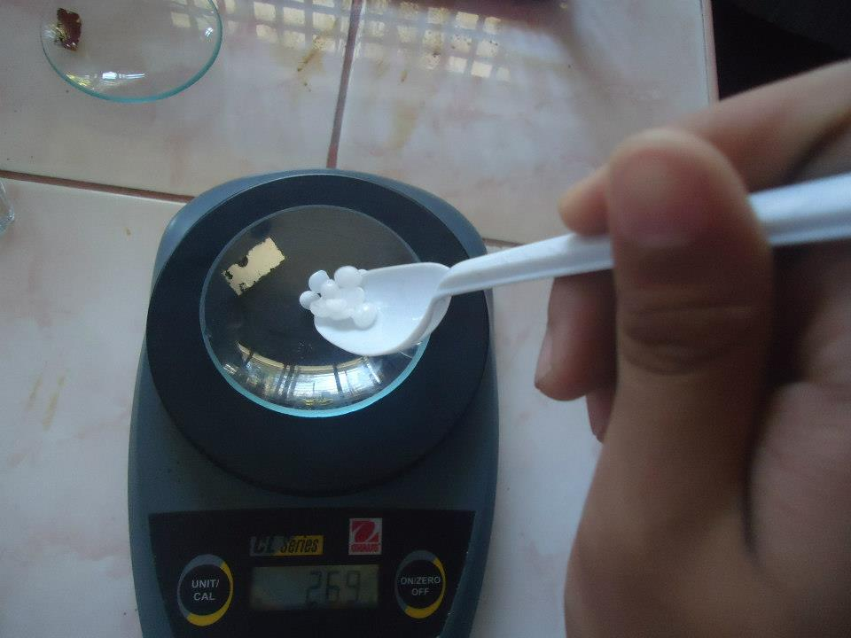
Measure the amount of NaOH that will be used in the experiment
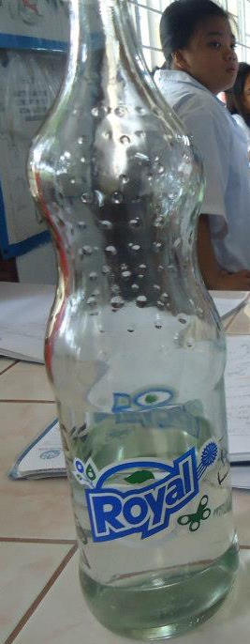
Pour 100 mL of distilled water into a clean bottle, and then add the NaOH.
Shake then label the solution.

- Titration of the HCl Standard Solution with the dilute NaOH solution
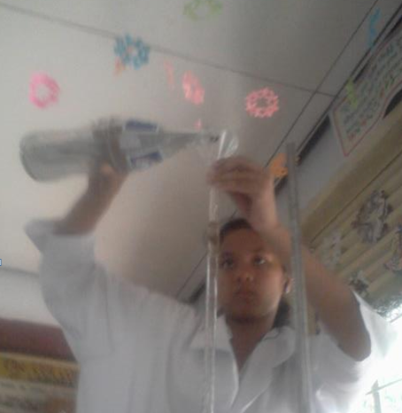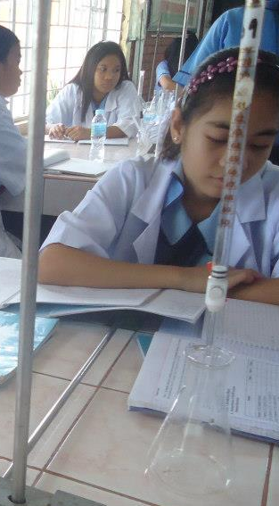
Rinse the buret with about 10 ml of the dilute NaOH solution.

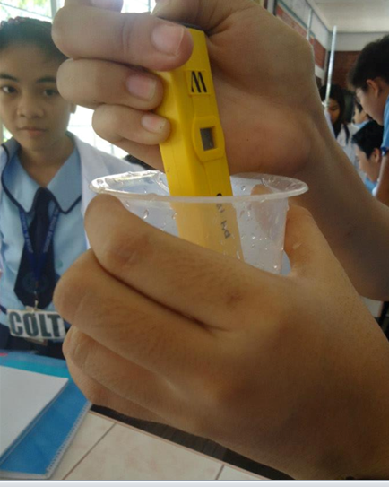
Measure the pH level of the solution

Measure 25 mL of the 0.1 M HCl standard solution with a pipet and transfer into an Erlenmeyer flask.

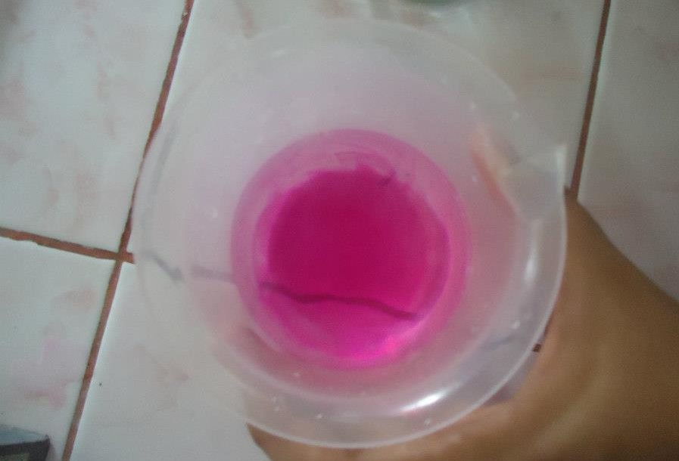
Add NaOH from the buret to the Erlenmeyer flask until it reached the color pink.

- Results and Discussions:

Details | Trial 1 | Trial 2 | Trial 2
Molarity of HCl Standard Solution | 0.1 M | 0.5 M | 1.0 M
no. of mmoles of HCl = no. Of mmoles H+ | 5.25mmol | 5.25mmol | 5.25mmol
no. Of mmoles NaOH reacted with HCl | 32 mmol | 200 mmol | 420 mmol
Final Reading (ml) NaOH Buret | 320 ml | 400 ml | 420 ml
Volume (ml) NaOH solution Delivered | 0.53 ml | 1.06 ml | 1.59 ml
Molarity of NaOH | 0.1 M | 0.5 M | 1.0 M
Average Molarity of NaOH | 0.53 | 0.53 | 0.53
Deviation | 0.154 | 0.23 | 0.4
Standard Deviation | 0.30 | 0.02 | 0.33
Relative Standard deviation (%) | 81% | 5.6% | 89%

- Conclusion:
- As the solution turns pinkish (in addition of phenolphthalein) it becomes more basic.

- References:
- http://www.google.com/url?sa=t&rct=j&q=&esrc=s&source=web&cd=5&ved=0CFAQFjAE&url=http%3A%2F%2Fimages.fonsyplantilla.multiply.multiplycontent.com%2Fattachment%2F0%2FS-

Leader:
Alleta Fae S. Liwag
________________
Members:

Zhenna Marriz Aypa
_________________
Mark Anthony Basilio
_________________
Kathleen Caralde
__________________
Cristel Diane Dela Cruz
__________________
Reagan Delos Reyes
___________________
Cristel F. Imbag
____________________
Jarlyn Liwag
____________________
Rosiel Mariano
_____________________

Submitted to Mr. Jeffey Sta Ines

